**Ideation Phase Brainstorm**

**& Idea Prioritization**

Template

|  |  |
| --- | --- |
| Date | 02 Oct 2022 |
| Team ID | PNT2022TMID42862 |
| Project Name | Personal Expense Tracker Application |
| Maximum Marks | 4 Marks |

# Brainstorm & Idea Prioritization Template:

Brainstorming provides a free and open environment that encourages everyone within a team to participate in the creative thinking process that leads to problem solving. Prioritizing volume over value, out-of-the-box ideas are welcome and built upon, and all participants are encouraged to collaborate, helping each other develop a rich amount of creative solutions.

Use this template in your own brainstorming sessions so your team can unleash their imagination and start shaping concepts even if you're not sitting in the same room.

# Step-1: Team Gathering, Collaboration and Select the Problem Statement

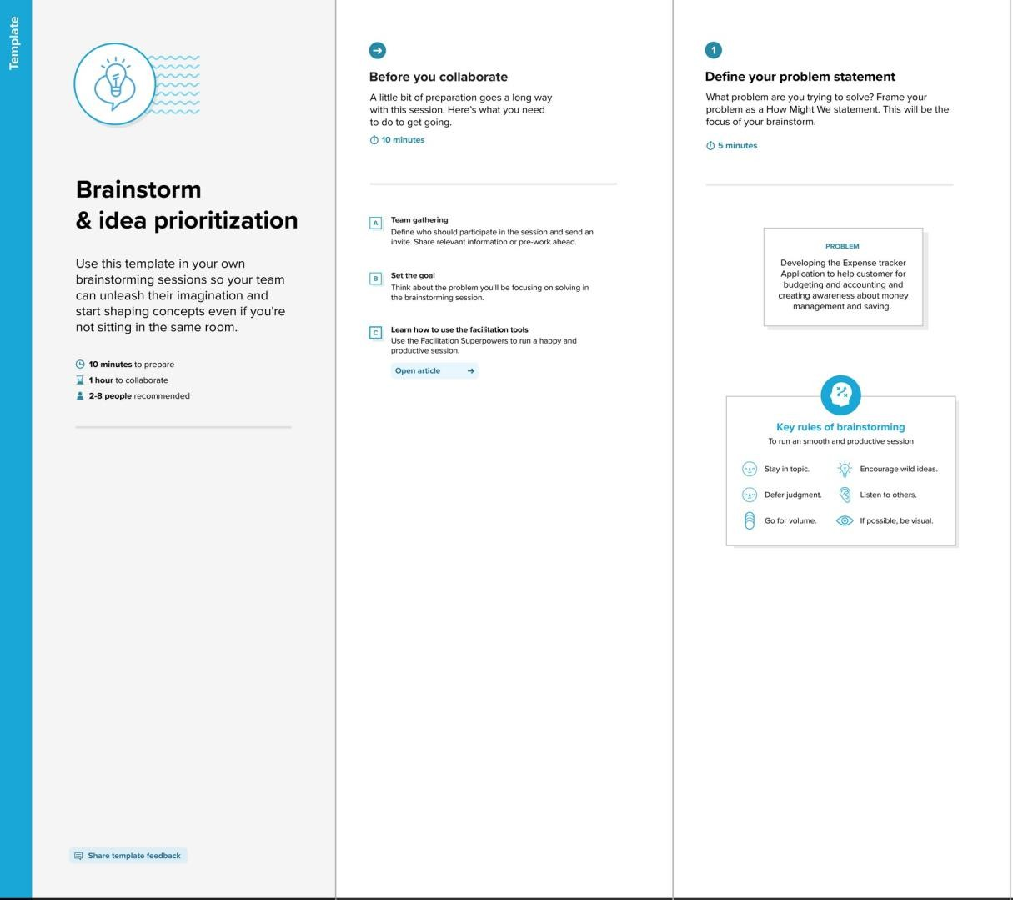

**Step-2: Brainstorm, Idea Listing and Grouping**

**Write down any ideas that come to mind that address your problem statement.**

**Manikandan Jagadeeshwaran**

Get monthly

Report as pdf or excel sheet

Ouath JWT integration

Reduce manual input

Create a additional steam of income

Limitations for budget

To user to enter the spending

Recommendation popup

Eye catching UI

Generate monthly report

Keep accurate records

**Mukilarasan Sudhakar**

To remind user to enter the spendings

Add multiple stream of income

Night mode

Language translation

Automate date from excel

Reduce user navigation

Overspending/underspending of money

Report generation in PDF

Show cash flow

Visualize the expenses

**Yogeshkumar**

Generate monthly record

Giving solutions on expenses

Scam detection

Remainder on loan

No need for complicated excel sheets

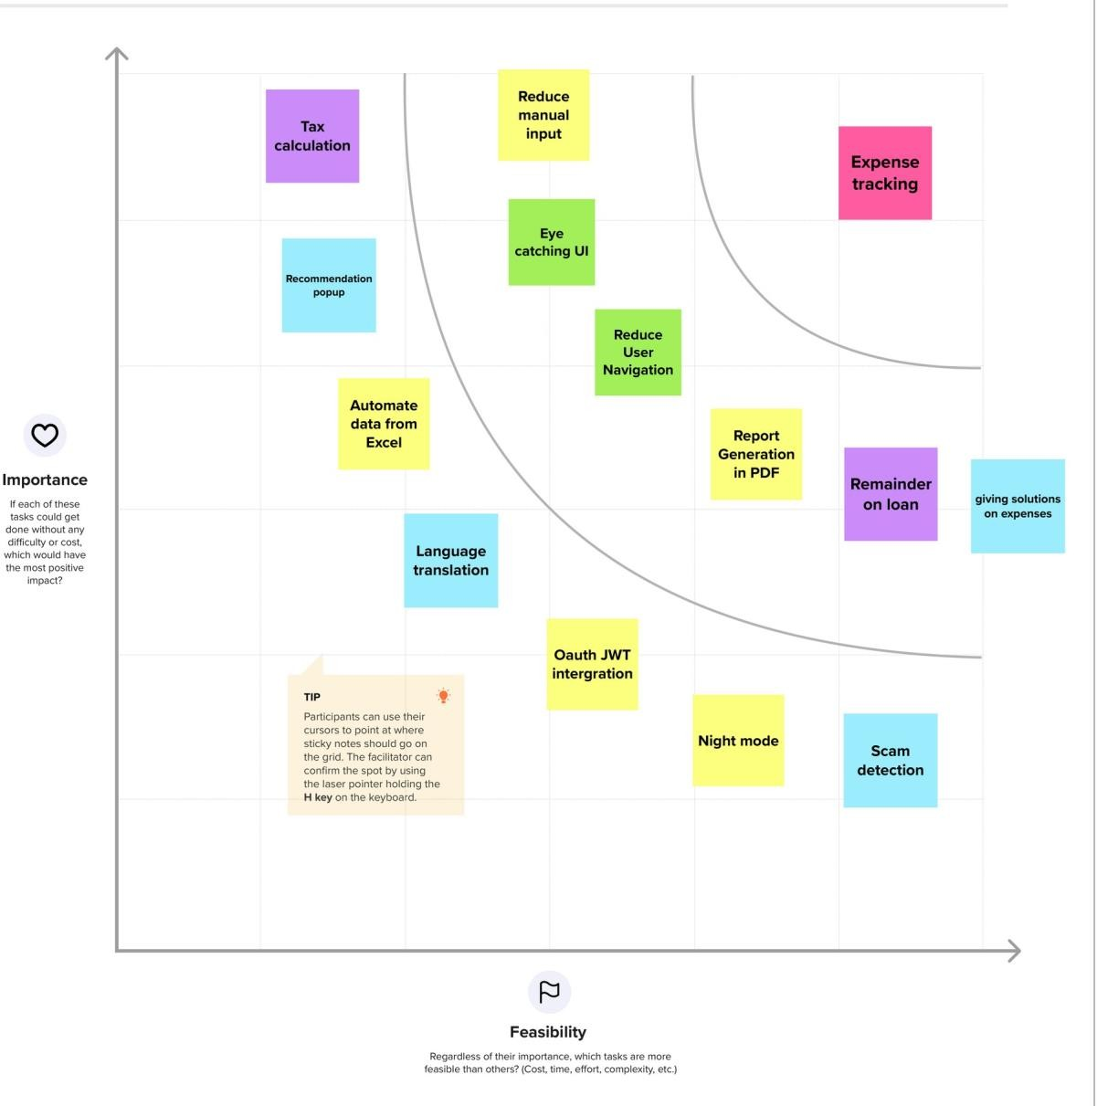**Step-3: Idea Prioritization**